The University of Chenab


Department of Computer Science

Title: | Task # 3
Subject: | Human Computer Interaction and computer Graphics
Submitted by: | Abdullah Tallat
Student ID: | BSSE012315010
Submitted to: | Mam Bisma Shahzadi
Date: | 8 March 2026

System Analyzed:
- University of Chenab Website Portal
Main Interface:
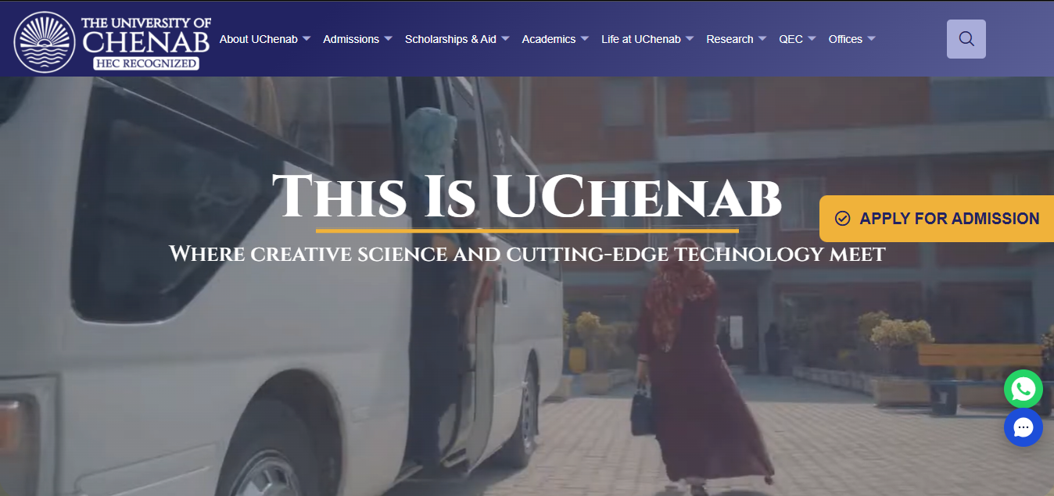

Introduction
Understanding user needs is important when evaluating or improving a website. One way to collect user feedback is through surveys, which help identify how people interact with a system and what problems they face.
For this assignment, a Google Form survey was conducted to analyze how students use the University of Chenab website portal. The responses helped in identifying user behaviour and creating user personas based on real data.
The main objectives of this survey were:
- To understand how students use the university website
- To identify usability problems in the portal
- To analyse common usage patterns
- To create user personas based on survey responses

Survey Methodology
A Google Form survey was created to collect feedback from students regarding their experience with the university portal.
Link for the google form:
- Survey link for university portal
Question asked in Survey Form:
Demographics
These questions help identify who the user is:
- Name
- Visit university portal as: Student / Faculty
- Have you ever visited the website before being admitted/employed to university? (Yes / No)
Technologies
These questions focus on how users access the website:
- Which device do you use to access the website? (Mobile / Laptop/PC)
- How is your loading speed while using the website? (Slow / Moderate / Fast)
- Website functionality rating (1–5)
- Which browser do you use? (Chrome / Firefox / Safari / Microsoft Edge)
Usage Patterns
These questions reveal user behavior and interaction with the website:
- Is the homepage easy to navigate? (Agree / Partially Agree / Disagree)
- Did you face any problems while clicking links? (Yes / No / Sometimes)
- Was it easy to find the information you needed? (Yes / No)
- Do the hyperlinks work properly? (Yes / No)
- How often do you visit the website? (Daily / Weekly / Monthly)
- For what purpose do you use the website most? (Admission, Fee & Enrollment, Results, Application Form)
- Are you satisfied overall with the university website? (1–5, Low–High)

Survey Feedback:
Demographics Section:
Timestamp | Name | Visit university portal as a | Visited before enrollment/employment?
3/5/2026 13:37:30 | Noor Fatima | Student | No
3/5/2026 13:38:34 | Sawera Ghaffar | Student | No
3/5/2026 13:41:30 | Ali Farooqi | Student | No
3/5/2026 13:51:56 | Human | Student | Yes
3/5/2026 13:56:53 | Wali | Student | Yes
3/5/2026 14:14:11 | Sami Ullah | Student | No
3/5/2026 17:30:16 | Danish Mahmood | Student | No
3/5/2026 17:35:47 | Adeena Noor | Student | No
3/5/2026 18:48:43 | Zara Fawaz | Student | No
3/5/2026 19:19:55 | Haseeb | Student | Yes
3/6/2026 11:43:16 | Aroosa Mir | Student | No
3/6/2026 16:07:57 | Ayesha Farooq | Student | No
3/7/2026 11:40:49 | Mirza Ali | Student | Yes
3/7/2026 12:18:37 | Abeera | Student | No
3/7/2026 12:19:43 | Adeena Noor | Student | No
3/7/2026 12:23:12 | Attiya Touqir | Student | No
3/7/2026 12:29:15 | Attiya Touqir | Student | No
3/7/2026 16:22:03 | Samavia | Student | No

Technologies Section:
Name | Device used to access site? | Loading speed? | Website functionality (1–5) | Browser used? | Do the hyperlinks work properly?
Noor Fatima | Mobile | Slow | 2 | Chrome | Yes
Sawera | Mobile | Slow | 1 | Chrome | No
Ali Farooqi | Mobile | Slow | 2 | Chrome | No
Human | Mobile | Moderate | 3 | Chrome | Yes
Wali | Laptop/Pc | Moderate | 4 | Chrome | Yes
Sami Ullah | Mobile | Moderate | 3 | Chrome | No
Danish Mahmood | Mobile | Moderate | 2 | Chrome | Yes
Adeena Noor | Mobile | Moderate | 4 | Chrome | Yes
Zara Fawaz | Mobile | Moderate | 2 | Chrome, Edge | Yes
Haseeb | Mobile | Slow | 1 | Chrome | Yes
Aroosa Mir | Laptop/Pc | Slow | 2 | Chrome | Yes
Ayesha Farooq | Laptop/Pc | Moderate | 1 | Chrome | No
Mirza Ali | Mobile | Slow | 1 | Chrome | Yes
Abeera | Laptop/Pc | Slow | 1 | Chrome | Yes
Adeena Noor | Mobile | Moderate | 4 | Chrome | Yes
Attiya Touqir | Laptop/Pc | Moderate | 3 | Chrome | Yes
Attiya Touqir | Mobile | Moderate | 3 | Chrome | Yes
Samavia | Mobile | Moderate | 2 | Chrome | Yes
Patterns Section:
Name | Homepage easy to navigate | Any problems clicking links? | Easy to find needed information | How often do you visit? | Main purpose of using website? | Overall satisfaction with website?
Noor Fatima | Agree | Sometimes | Yes | Monthly | Admission, fee & enrollment, results, application form | 2
Sawera Ghaffar | Disagree | Yes | Yes | Weekly | Fee & enrollment, results | 1
Ali Farooqi | Partially agreed | Yes | No | Monthly | Fee & enrollment, results | 3
Human | Agree | Sometimes | Yes | Daily | Admission, fee & enrollment, results, application form | 2
Wali | Agree | Yes | No | Monthly | Results | 3
Sami Ullah | Partially agreed | Yes | No | Weekly | Admission, fee & enrollment, results, application form | 3
Danish Mahmood | Partially agreed | Sometimes | No | Weekly | Fee & enrollment, results, application form | 2
Adeena Noor | Agree | No | Yes | Weekly | Fee & enrollment, results | 4
Zara Fawaz | Agree | Sometimes | Yes | Weekly | Fee & enrollment, results, application form | 3
Haseeb | Agree | Yes | Yes | Daily | Admission purpose | 1
Aroosa Mir | Disagree | No | No | Monthly | Fee & enrollment | 2
Ayesha Farooq | Disagree | Yes | Yes | Monthly | Fee & enrollment, results | 1
Mirza Ali | Agree | Yes | Yes | Weekly | Admission purpose | 1
Abeera | Partially agreed | Sometimes | No | Monthly | Application form | 2
Adeena Noor | Agree | No | Yes | Weekly | Fee & enrollment, results | 4
Attiya Touqir | Partially agreed | No | No | Monthly | Admission, results | 3
Attiya Touqir | Partially agreed | No | No | Monthly | Admission, fee & enrollment, results, application form | 3
Samavia | Agree | Yes | Yes | Monthly | Fee & enrollment | 3

Survey Analysis:

Demographics:
Question | Option | Count | Percentage
Visit portal as | Student | 17 | 100%
 | Faculty | 0 | 0%
Visited website before admission/employment | Yes | 4 | 24%
 | No | 13 | 76%

Technologies:
Question | Option | Count | Percentage
Device | Mobile | 13 | 76%
 | Laptop/PC | 4 | 24%
Loading speed | Slow | 7 | 41%
 | Moderate | 10 | 59%
 | Fast | 0 | 0%
Browser | Chrome | 16 | 94%
 | Microsoft Edge | 1 | 6%
 | Firefox / Safari | 0 | 0%
Website functionality | 1 | 7 | 41%
 | 2 | 4 | 24%
 | 3 | 3 | 18%
 | 4 | 3 | 18%
 | 5 | 0 | 0%

Patterns:
Question | Option | Count | Percentage
Homepage easy to navigate | Agree | 7 | 41%
 | Partially Agree | 6 | 35%
 | Disagree | 4 | 24%
Problems clicking links | Yes | 3 | 18%
 | No | 5 | 29%
 | Sometimes | 9 | 53%
Easy to find information | Yes | 12 | 71%
 | No | 5 | 29%
Hyperlinks work properly | Yes | 13 | 76%
 | No | 4 | 24%
Frequency of website visits | Daily | 3 | 18%
 | Weekly | 8 | 47%
 | Monthly | 6 | 35%
Purpose of use | Fee & Enrollment | 11 | 65%
 | Results | 10 | 59%
 | Admission Purpose | 6 | 35%
 | Application Form | 6 | 35%
Overall satisfaction | 1 (Lowest) | 5 | 29%
 | 2 | 4 | 24%
 | 3 | 4 | 24%
 | 4 | 2 | 12%
 | 5 (Highest) | 2 | 12%

Key Findings:

Device Used
Device | Observation
Mobile | Majority of users
Laptop/PC | Few users
Most students access the university website using mobile devices.

Loading Speed
Speed | Observation
Slow | Many users
Moderate | Majority
Fast | None
Users experience slow to moderate loading speed, indicating performance issues.

Browser Usage
Browser | Usage
Chrome | Majority
Microsoft Edge | Few
Most users access the website through Google Chrome.

Website Usability
Question | Majority Response
Homepage easy to navigate | Agree / Partially agree
Problems clicking links | Sometimes
Information easy to find | Mostly yes
Finding:
Navigation is mostly understandable, but some link issues occur.

Website Usage Purpose:
Most users visit the website for:
- Checking results
- Fee and enrollment
- Admission information
- Application forms
Finding:
These functions are the most important tasks for students.

Overall Satisfaction
Rating | Observation
1–2 | Many users
3 | Some users
4–5 | Few users
Finding:
Overall satisfaction with the website is low to moderate.
Results:
- Students primarily use mobile devices to access the portal.
- Website loading speed is slow for many users.
- Some users experience problems with hyperlinks.
- The most frequently used features are results and fee information.
- Overall user satisfaction with the website is not very high.

User Persona:
A persona is a fictional representation of a typical user based on real research data. Personas help designers understand the needs, goals, and frustrations of users.

Persona 1: Mobile Student User
Name: Noor Fatima
Age: 20
Role: Undergraduate Student
Education: BS Software Engineering
Device: Mobile Phone
Browser: Chrome

Goals
- Check exam results
- Pay semester fees
- Submit application forms

Behavior
- Visits the portal weekly or monthly.
- Uses mobile for quick access.

Pain Points
- Slow loading speed
- Sometimes hyperlinks do not work properly
- Difficult navigation on mobile

Needs
- Faster website performance
- Mobile-friendly design
- Easy access to results and fee section

Persona 2: Laptop User
Name: Wali
Age: 22
Role: University Student
Education: BS Computer Science
Device: Laptop

Goals
- Check academic results
- Access university information

Behavior
- Visits the portal occasionally.
- Prefers laptop for detailed browsing.

Pain Points
- Moderate loading speed
- Difficulty locating some information

Needs
- Organized website structure
- Clear navigation menu

